CATEGORY: EYES

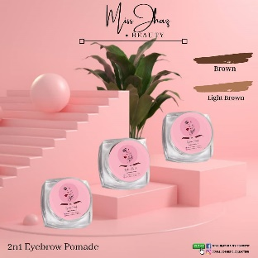

PRODUCT NAME: EYEBROW POMADE 2N1

PRICE: 100 Php

DESCRIPTION:

Available shades:

* Brown
* Light brown

Benefits:

* Wax type
* Light weight
* smudge proof
* Waterproof resistance

Eyebrow pomade upgraded in 2n1 shades that you can use for lighter or darker your brow. Our ultimate brow pomade allows you to create the perfect brow. It includes a detachable brush for easy application.

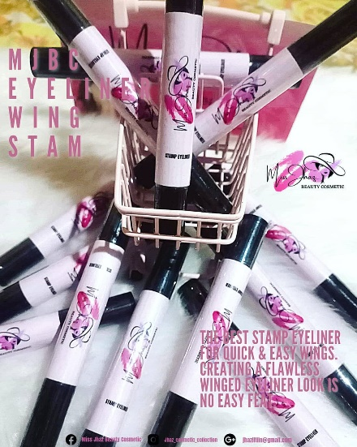

PRODUCT NAME: Eyeliner Wing Stamp

PRICE: 160 Php

DESCRIPTION:

New released of MJBC eyeliner wing stamp. Eyeliner stamps–a felt-tip eyeliner pen with a smudge-proof wing stamp on the end–take away half the time and precision required to apply fierce, feline flicks.

Eyeliner Wing Stamp is a double-ended wing stamp pen and accompanying liquid liner that make it super easy to get your best winged eyeliner.

How to Use?

* Stamp: Position the wing-shaped stamp at the outer edge of the eye, and press down firmly—the wing should connect to the lower lash line, creating one continuous line.
* Line: Use the eyeliner pen to draw along the lashes and connect the wing. Shake well before use.
* Repeat on the other side.

Benefits:

* Cruelty-Free
* Long-wearing
* Vegan
* Waterproof

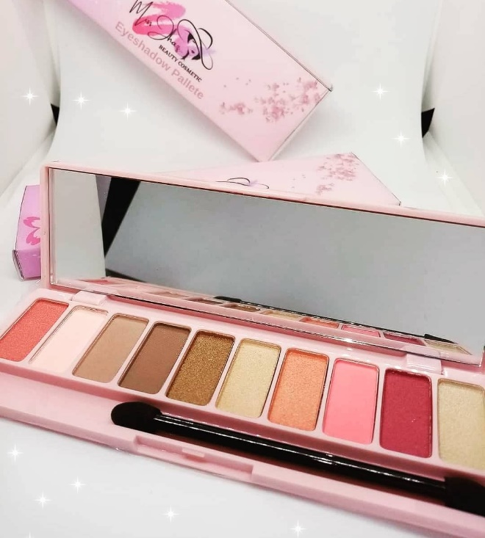

PRODUCT NAME: Sakura Edition Eyeshadow Palette

PRICE: 199 Php

DESCRIPTION:

Always have a classic vibe look with our Sakura Inspired Eyeshadow Palette 10 color shades + all the bright pigmented colors you desire.

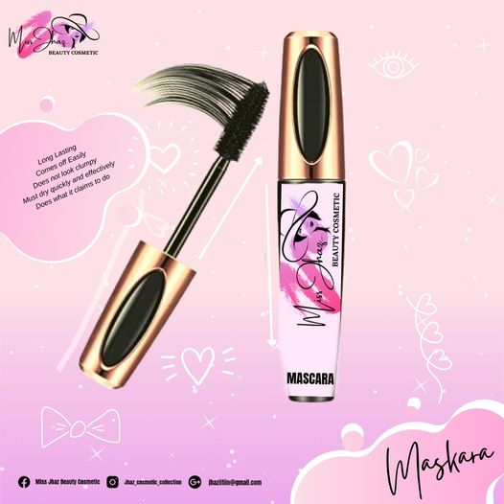

PRODUCT NAME: Maskara

PRICE: 180 Php

DESCRIPTION:

It’s time to stop the eye drama. Avail MJBC MASKARA and it may darken, thicken, lengthen, or define your eyelashes. Drawing more attention to your eye.

Benefits:

* Long lasting
* Comes off easily
* Does not look clumpy